Instructor Brendan Wylie-Toal
SVENT 325
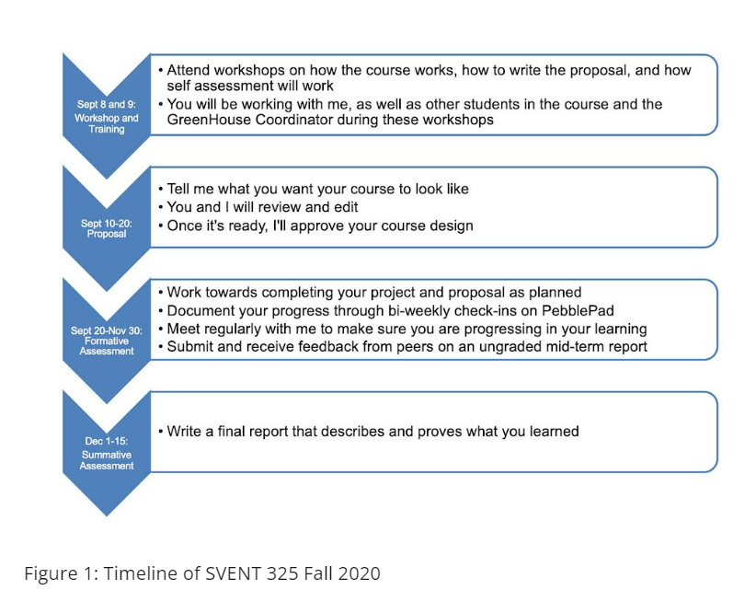
Learning Outcomes and grading:
SVENT 325 Learning Outcomes
This course will be assessed using specification-based grading. The tiers and requirements for each tier are provided below.
Peer and Self-evaluation: Students will be asked to both self-assess their work, as well as the work of at least one other student. The structure and process for this will be discussed in one of the two introductory workshops.
Assessment details: As a student in SVENT 325, you will be assessed on your ability to critically reflect upon your learning experiences in the course. In other words, the design and content of the PebblePad portfolio you're going to build will not be assessed. Rather, you will be assessed on the quality of your reflections as demonstrated through the evidence and reflections contained within your Final Reflective Report.
In addition, your PebblePad based e-portfolio will support and provide evidence for your learning and development of skills throughout your course. Your portfolio should be constructed and maintained throughout the course, demonstrating evolution, iteration and progress over-time. It must include a regular reflective blog diary. It should contain other evidence, which may take many forms including photographs, documents, reports, feedback, video, podcasts, etc.
In addition, you'll be asked to demonstrate your understanding of your achievements through self-assessment. In your self-assessment, you are required to demonstrate the alignment of the grades given by you for each learning outcome to the justification for them, and where this is evidenced within your portfolio. The self-assessment does not contribute to your final mark.
You may be asked to review a number of your peers' Final Reflective Reports. This will provide you with an opportunity to learn about the projects of other students, as well as how they have engaged with the reflective process.
Specifications-based grading tiers for SVENT 325 F20
0-49% | - Complete the learning proposal  - Attend 50% or few meetings  - Complete 50% or few blog posts/reflections  - Receive an average of ‘insufficient’ on the final report
50-59% | - Complete the learning proposal  - Attend 50% or few meetings  - Complete 50% or few blog posts/reflections  - Receive an average of ‘sufficient’ on the final report
60-69% | - Complete the learning proposal  - Attend 60-69% of meetings  - Complete 60-69% of blog posts/reflections  - Receive an average of ‘sufficient’ on the final report
70-79% | - Complete the learning proposal  - Attend 70-79% of meetings  - Complete 70-79% of blog posts/reflections  - Receive an average of ‘sufficient’ on the final report
80-89% | - Complete the learning proposal  - Attend 80-89% of meetings  - Complete 80-89% of blog posts  - Receive an average of ‘good’ on the final report
90-100% | - Complete the learning proposal  - Attend 90-100% of meetings  - Complete 90-100% of blog posts  - Receive average of ‘excellent’ on final report

