In PSCI 494 Current Issues in Political Science students are required to select a current issue/topic in political science to examine by attending talks, monitoring print and online media, and doing independent research. Typically, the topic needs to have contemporary relevance and something that cannot be researched adequately using only library print sources.

PSCI 494 is designed as a SLICC course (student-led, independently-created course). Students are required to plan, propose, carry out, reflect on and evaluate on their learning experience as they conduct research on their chosen current issue/topic. Throughout the course you will develop a range of skills and attributes (academic, professional and/or personal) which will help you to engage effectively with your experience. You will be encouraged to evaluate and critically reflect upon your approach, learning and development.

Course Expectations and Due Dates
Once you have selected your current issue, the first assignment is the submission of a proposal that will identify and define the current issue selected. The work in this course is self-guided. Therefore, students are expected to demonstrate independent learning and gain the experience-based skills needed to investigate how a concept/issue in political science plays out in contemporary politics, policy and governance.

Students will present their research in the form of a final project that must not be a standard written report. Instead we encourage students to work on a creative final output such as a blog, website, video, podcast, poster board etc.

In parallel, students will also be reflecting on their research approach, learning and development throughout the course. These reflections will be compiled in the form of a mid-term report (due in Week 8) and a final reflective report (due at the end of the semester).

The timeline below provides an overview of course assignments and when they are due.
Check-in with Dr. Mufti | January 16 to 18 on MS Teams.  Duration of meeting is 30-45 minutes.
Proposal | January 27, 2023, at 12 pm
Mid-term Report | March 10, 2023, at 12 pm
Check-in with Dr. Mufti | March 13 to 16 on MS Teams.  Duration of meeting is 30 minutes
Final Reflective Report +Self-Assessment | April 6, 2023, at 12 pm
Final Project | April 17, 2023, at 12 pm

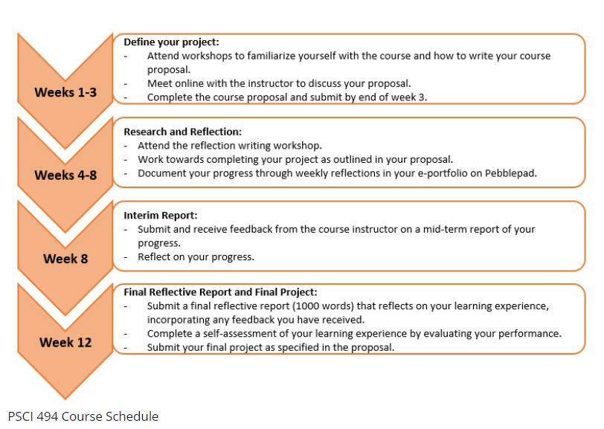
Course Grading
Grading in this course is a combination of student self-assessment and instructor assessment.
Students are responsible for assessing their progress towards the learning outcomes defined in their proposal. To do this, students will review and assess their reflections on Pebblepad, the interim report and the final reflective report. Students must justify the numerical grade they assign to themselves based on a self-assessment rubric (provided). This will be 30% of the total grade in the course.
The remaining 70% of the grade will be assessed by the course instructor and will comprise of the proposal (20%) and the final project (50%).
In summary:
- Proposal 20%
- Final Project 50%
- Self-assessment (including reflections, interim report and final reflective report) 30%
Part 2: Self-Assessment
Having completed your Final Reflective Report you are now ready to complete your Self-Assessment.
You should self-assess your course by grading each Learning Outcome separately against the assessment criteria provided in the course proposal and the self-assessment rubric.
In addition, you must provide an explanation, justifying why you gave yourself these particular grades, for each of the specific Learning Outcomes. You should also indicate where in your collection of evidence you believe you have demonstrated this level of achievement for each Learning Outcome.
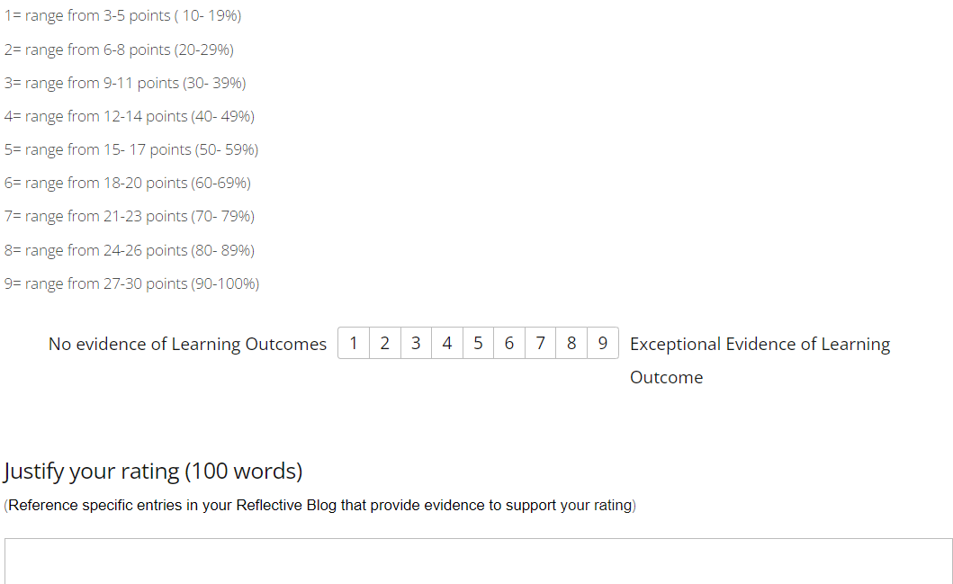
Final Project
The final project must investigate how the chosen current issue plays out in contemporary politics, policy and governance. We expect students to present their research in the form of a creative final output such as a blog, website, video, podcast, poster board etc . Other options, chosen at the student’s discretion, include submitting a blog or daily journal, creating a website, a photo essay, a mock newspaper article or opinion editorials, a poster presentation, a slide deck (created in Power Point or Prezi), a vlog/documentary/video (with accompanying written abstracts or blurbs), or an audio recording of a mock radio interview with written transcript.
Any final project in an audio-visual format must be accompanied by a written transcript.
The final project will be graded by the course instructor. It is worth 50% of your grade.

A detailed grading rubric is given below:
